EYEWEAR ECOMMERCE · SRI LANKA

FLEXER Website Overview
A product-led online eyewear experience built around considered design and optical confidence.
FLEXER is a Sri Lankan eyewear storefront for sunglasses and optical frames. The site brings together curated collections, product discovery, a guided checkout, local customer care, and clear service information in one responsive experience.
Its visual direction pairs warm ivory and white surfaces with restrained gold details, editorial typography, and close-up frame photography. The home page opens with a cinematic hero video and uses gentle on-scroll reveals to carry visitors through the collection and brand story.
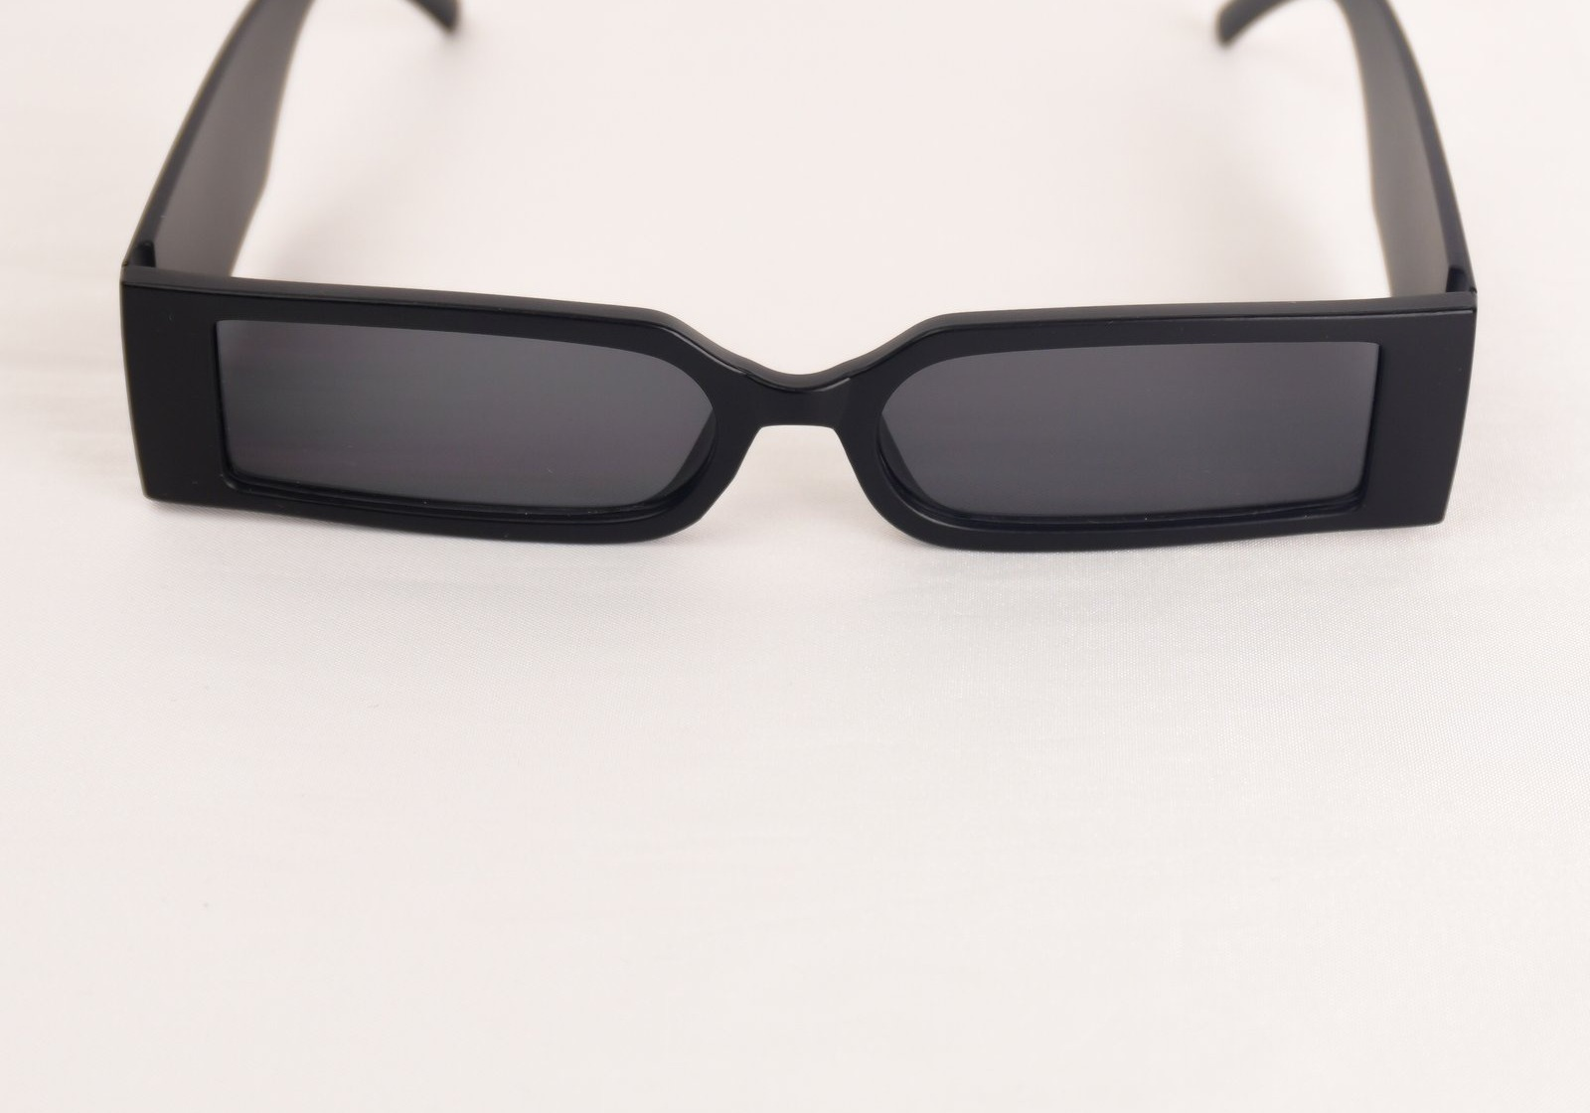
Selected product photography used on the storefront

COLLECTIONS AND CATALOGUE

Three ways to find your frame
The catalogue is organised into three curated ranges so visitors can quickly compare everyday value, premium materials, and collector-level options. Prices are shown in Sri Lankan rupees.
Range | Indicative price | Positioning
Budget | LKR 1,690–4,690 | Contemporary everyday frames with UV400 filtration and practical care essentials.
Premium | LKR 7,560–9,990 | Italian-acetate styling, polarized optics, and a more elevated presentation.
Branded | LKR 23,000+ | Collector-focused designs, premium materials, and extended presentation and warranty benefits.

What shoppers can do
Visitors can browse by collection, product type, range, and colour; search and sort the catalogue; compare product photos and available variants; and open quick views from product cards. Product pages present frame details, options, prices, and add-to-bag actions. The shopping bag keeps selected items visible as shoppers continue browsing.
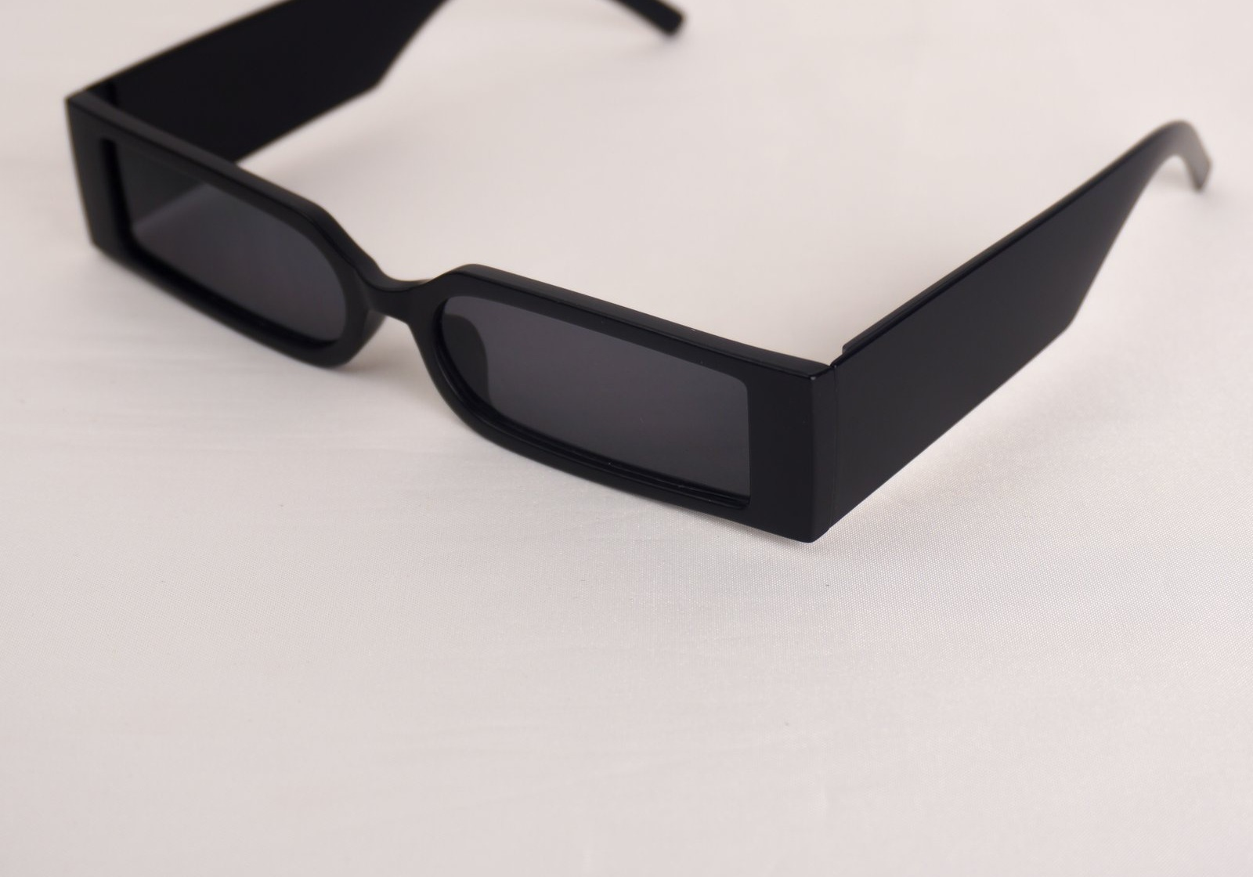
A closer view of the frame photography presented across product discovery

SHOPPING, SERVICE, AND BRAND

A clear path from discovery to delivery
The shopping flow moves from collection browsing to product selection, a persistent bag, and a dedicated checkout form for customer and delivery details. Checkout supports bank transfer, cash on delivery, and Koko instalments. For bank transfer, customers can share a payment slip directly with the business through WhatsApp; the website states that these slips are not uploaded to its server.

Optical confidence and customer care
Across the storefront, FLEXER highlights UV400 protection and optometry-informed frame selection. Product and collection content is supported by an about page, customer testimonials, frequently asked questions, an email newsletter sign-up, and direct WhatsApp support at +94 77 558 0968. The site also promotes an official WhatsApp community for drop announcements and updates.

Main pages
Home · Shop all · Sunglasses · Optical frames · Budget, Premium, and Branded collections · Product details · Shopping bag and checkout · About FLEXER · Contact and support · Shipping · Returns and exchanges · Warranty · Privacy · Terms and conditions.

Social pages
TikTok @flexer737 Facebook FLEXER on Facebook

Storefront and merchant access
The public-facing site is focused on product discovery, customer service, and ordering. Merchant administration is kept off the customer navigation and is intended for authorised operators through a separate direct entry point.
In short, FLEXER combines an editorial eyewear presentation with the practical tools of a local online store: curated products, a working basket and checkout, Sri Lankan payment choices, and direct customer support.

